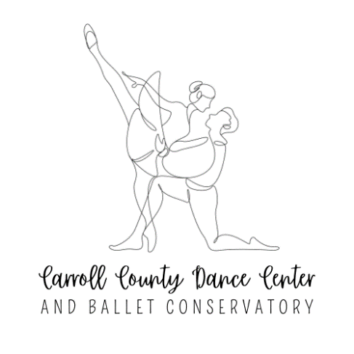

Our youngest dancers have the opportunity to perform for their families and friends in our Spring Dance Concert the weekend of June 7-8 at South Carroll High School. This concert gives these very young dancers a chance to be onstage in an environment geared specifically for them.

The dancers will learn about and perform selections from the classical ballet Paquita. This portion of the performance will last approximately 30 minutes. During the intermission, these dancers will take a seat in the audience and watch a special Company performance prepared especially for them, featuring more experienced dancers in ballet, jazz, modern, hip-hop and tap pieces. Students will do most of their preparation for the concert in class with their teacher. There will be a full rehearsal on Saturday, May 31st at the dance studio and a dress rehearsal at the theatre on Saturday, June 7th. The performance will be held on Sunday, June 8th. All of the rehearsals are mandatory, as it is the familiarity with the surroundings that makes the event enjoyable and comfortable for these young dancers. Detailed rehearsal schedules and performance times will be announced in the spring.

All of the teachers are looking forward to instilling performance skills and discipline which foster a positive learning experience for each dancer. Parental and family support is vital to the success of each dancer and to the production as a whole. Insuring prompt and steady attendance at all classes and rehearsals is essential. Your child needs your encouragement in order to do their best. The Carroll County Dance Center has a reputation for wonderful, professional productions. The dancers, however young, are aware and proud of this professionalism and know that it comes from each of them. Please support them as they learn about commitment, punctuality, and cooperation. Such an attitude nurtures the team spirit and physical strength so crucial to dance and promotes a great feeling of achievement.

Please initial each item and sign below:

I understand that my performance and costume fees have been paid with my Gift of Dance registration, however tickets for the performance ($12 each) are sold separately.

My dancer will attend all regularly scheduled classes unless ill.

My dancer will attend rehearsals on May 31st and June 7th.

During the performance dancers will remain backstage with their class, teachers, and
chaperones until the entire performance is over.

Parents will remain in the audience until the performance is entirely finished. If a parent is needed backstage, someone will come find them.

I agree to have my dancer attend classes through June 9th, 2025.

I have read all the materials, understand the commitment, and look forward to my child’s participation in the 2025 Spring Concert.

Your completed registration confirms your acknowledgement and acceptance of the above terms.

